* **Lab Task 4**

Write a SQL statement that uses a subquery to find those countries where the population is greater than or equal to 200 million. Return all the fields of those countries.

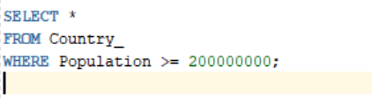

OUTPUT:

